Abstract  
  
By integrating FaxCore with the ShoreTel System, the customer can have a complete telephony solution for both voice and fax. Faxes can be sent through the ShoreTel System directly from any application or from a user’s email client, and can be automatically routed to a user’s email inbox.

Contents

Abstract 1

Overview 2

Features and Benefits 2

FaxCore Overview and Contact 2

FaxCore Product Information 3

Architecture Overview 3

Call Flow When Receiving Faxes 4

Call Flow When Sending Faxes 4

Requirements, Certification and Limitations 4

Version Support 5

Certification Testing Results Summary 6

T.38 Fax Applications 8

Application 1 –One Main Number for Both Voice and Fax –Fax Redirect 8

ShoreTel Configuration 8

Application 2 –User with a Unique Voice Extension and a Unique Fax Extension 16

FaxCore Configuration 22

Configuration for the FaxCore/Dialogic Brooktrout SR140 22

# Overview

This document is meant to provide information about FaxCore Software and its product FaxCore, describing how FaxCore can integrate with the ShoreTel System to provide a complete telephony solution. This document will tell how to contact FaxCore Software and it will provide product specifics, interoperability testing results, typical setup configurations, troubleshooting steps and other important product-related information.

# Features and Benefits

* Automatically route incoming faxes to the appropriate recipient
* Send faxes from any application
* Integration with Active Directory
* FoIP Support
* Archive faxes to FaxCore or SQL
* Supports Microsoft Exchange, Lotus Notes and other Simple Mail Transfer Protocol (SMTP) mail servers
* Support for Citrix
* Fax Broadcasting using Microsoft Office Mail Merge
* Support for Microsoft Outlook Contacts
* Reports for Fax Usage
* Integration with industry-leading fax board manufacturers

# **FaxCore Overview and Contact**

FaxCore Software provides a single source of Web & Mail Security, Archiving, Backup & Fax, Networking & Security and Hosted solutions software for small to medium-sized enterprises. With award-winning technology, an aggressive pricing strategy, and a strong focus on the unique requirements of small to medium-sized enterprises, FaxCore Software satisfies the needs of SME organizations on a global scale.  
FaxCore Software has offices in USA (Colorado & New Jersey), Malaysia, Australia, which support hundreds of thousands of installations worldwide and is a channel-focused company with a global network of thousands of partners. FaxCore Software is also a Microsoft Gold Certified Partner.   
  
For general sales questions, please contact your reseller or contact FaxCore Software directly at:

**FaxCore Sales**   
(888)905-4881   
[sales@faxcore.com](mailto:sales@faxcore.com)

FaxCore Product Information

With FaxCore, less time is spent on sending, collecting and distributing faxes, saving your company noticeable costs. Faxes sent/received are also saved in digital format as an email attachment.  
FaxCore is easy to install, requires little maintenance and integrates with existing messaging clients and  
customized solutions. It seamlessly integrates with your mail server, allowing users to send and receive faxes using their email client. Your company can also search for and back up all faxes in the same way that emails are stored and retrieved on the network.

FaxCore supports analog, digital, and Fax over IP (FoIP) connectivity options. For FoIP, it integrates with IP enabled PABXs and Brooktrout’s SR140 technology to send faxes over an IP infrastructure. FaxCore is an award-winning fax server and has been voted #1 by Windows IT Pro readers for 3 years running.

Architecture Overview

FaxCore sits on the network and users connect to FaxCore via their Desktop browser or via their Email client. See the diagram below.

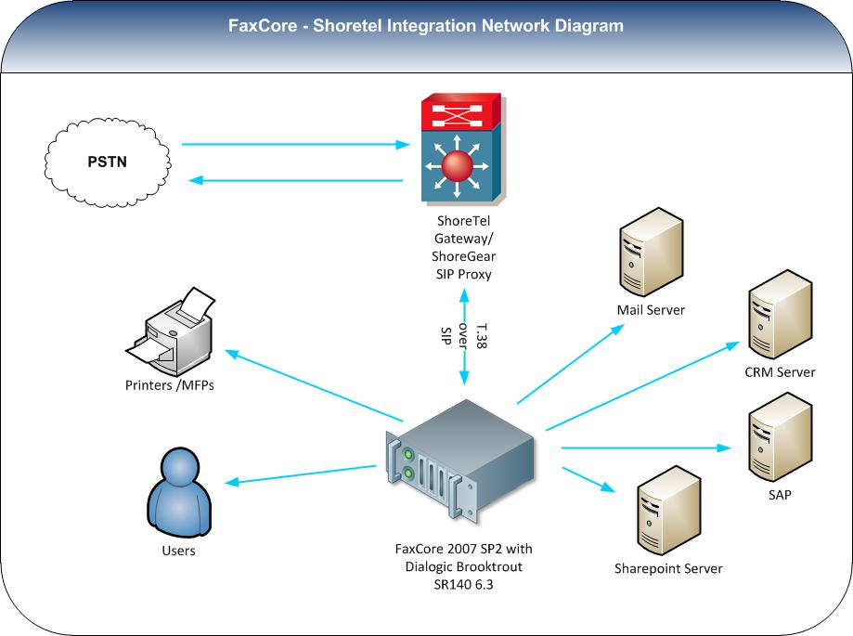

Figure 1 –Call Flow Diagram

Call Flow When Receiving Faxes

When the ShoreTel system detects that an inbound call is a fax call, the call is routed to the fax device located in the FaxCore server. This fax device receives the fax and provides it to the FaxCore application. After conversion to the desired format (PDF, TIF, GIF, JPG, or PNG), FaxCore attaches the received fax to an email transmission report and sends it to the email server for delivery to the designated user.

Call Flow When Sending Faxes

Internal users send an email to either a business fax contact or to number@faxserverdomain.com which is then routed by the email server to the FaxCore server. FaxCore converts the email and any attachments to a fax format and utilizes the fax device for transmission to the ShoreTel system. The ShoreTel system handles the connection between the fax device and the public switched telephone network (PSTN) cloud. After the successful or unsuccessful transmission of the fax, FaxCore sends an email transmission report back to the sender of the email with the status.

Requirements, Certification and Limitations

**Hardware**

* CPU: Pentium 4 (2.0Ghz or higher)
* Memory: 4 GB RAM
* Disk Space: 20 GB available disk space (additional disk space will be required for storing fax messages)
* Fax Board: Fax communication device present

**For PSTN:**

* Dialogic Brooktrout TR1034 Series Fax Board (full length and full height PCI board, board will require 12.5” of room in PCI slot)
* Dialogic Brooktrout TruFax Series Fax Board

**For Fax over IP:**

* Dialogic Brooktrout SR-140 *

**Operating System – Platform**

* Windows Server 2008 64 bit R2  
  *with Microsoft .NET 3.5 installed.
* VMware Virtual Machine with either of the supported Operating Systems installed.  
  *64 Bit is support, but both FaxCore and the Dialogic Brooktrout drivers run in 32 bit mode.
* Citrix Xen Server with either of the supported Operating Systems installed.

**Operating System – Configuration Recommendation**

* Fresh installation (not an OS upgrade)
* Microsoft .Net 3.5 installed
* Static or DHCP reserved IP address
* Do not join the FaxCore server to your Domain.

**Client Software Requirements**

* Microsoft Internet Explorer 6.0 or later, Firefox or Safari

**Notes on ShoreTel requirements:**

* All ShoreTel ShoreGear Switches that participate in a T.38 fax call MUST support T.38 protocol
* The fax machine/fax server behind the ShoreTel PBX should disable V34 to avoid using the G711/Linear clear channel V.34 faxes are not supported
* ShoreTel only supports T.38 in udptl form. T.38 calls in RTP or TCP forms are not supported at this time
* ShoreTel does not support either IP media or RFC2833-based fax tone detection (in RFC2833, ShoreTel only supports DTMF, no named telephony events).
* ShoreTel depends on fax CNG tone detection or T.38 invite to redirect an incoming fax call. If the fax connection is established with on SIP-based endpoint (such as SIP extension or SIP trunk), ShoreTel depends on the invite to either establish a fax connection or redirect the call to a preconfigured fax device.
* T.38 support is not supported on SIP-BRI

Version Support  
Note: FaxCore 4370 is no longer supported by FaxCore.

|  |  |  |
| --- | --- | --- |
|  | | **FaxCore Release** |
| 2007 SP2 |
| **ShoreTel Release** | 10.x | ✓ |
| 11.x | ✓ |

Table 1 - Supported Software Version Matrix

**Special considerations:**The following switches do not support T.38 protocol. For those and older switches, G711/L16 clear channel is used for fax purposes.

* ShoreGear –8
* ShoreGear –12
* ShoreGear- 120
* ShoreGear –T1
* ShoreGear –E1
* ShoreGear –TW
* ShoreGear –24 and ShoreGear –24a

## **Certification Testing Results Summary**

Table 2 - Initialization and Basic Feature Test Cases

|  |  |  |  |
| --- | --- | --- | --- |
| **ID** | **Name** | **Description** | **Results** |
| 1.1 | Configure a User for Testing with FaxCore | ShoreTel Certification lab will add a user to the FaxCore Server for use. | Pass |
| 1.2 | Sending Faxes with FaxCore Client | ShoreTel Certification lab will use the FaxCore Client to send a Fax to a Fax Machine using FoIP and the ShoreGear SIP Proxy switch. | Pass |
| 1.3 | Receiving Faxes with FaxCore | ShoreTel Certification lab will receive a fax from an external fax machine to a mailbox (either Internet mail or local mail). | Pass |
| 1.4 | Inbound Fax calls are redirected when ShoreTel user answers call | ShoreTel user will receive a fax from an external fax machine, answer the call, CNG tones will be presented, the call will redirect to FaxCore for delivery to designated user. | Pass |
| 1.5 | Inbound Fax calls are redirected when call is not answered and forwards to ShoreTel users voice mail | ShoreTel user will receive a fax from an external fax machine, user does not answer the call, the call will redirect to FaxCore for delivery to designated user. | Pass |
| 1.6 | Inbound Fax calls are redirected when ShoreTel user selects “To VM” | ShoreTel user will receive a fax from an external fax machine, user decides not to answer the call, and selects “To VM” to forward the call to their mailbox, the call will redirect to FaxCore for delivery to designated user. | Pass |
| 1.7 | Inbound Fax calls are redirected when ShoreTel user is configured to “Always Forward” their calls to voice mail | ShoreTel user will receive a fax from an external fax machine, user is configured with their Call Handling Mode to “Always” forward the calls to their mailbox, the call will redirect to FaxCore for delivery to designated user. | Pass |
| 1.8 | Sending Faxes with FaxCore Client via SIP Trunks  (Refer to Note below) | ShoreTel Certification lab will use the FaxCore Client to send a Fax to a Fax Machine using FoIP and the ShoreGear SIP Proxy switch. | Pass |
| 1.9 | Receiving Faxes with FaxCore via SIP Trunks  (Refer to Note below) | ShoreTel Certification lab will receive a fax from an external fax machine to a mailbox (either Internet mail or local mail). | Pass |
| 1.10 | Receive a Transmission Report with FaxCore | ShoreTel Certification lab will send a fax and receive a Transmission Report using FaxCore. | Pass |

NOTE: Fax redirect is not supported when inbound calls are routed through SIP trunks. A separate fax phone number (DNIS/DID) needs to be configured to route directly to the FacCore FoIPBox.

Table 3 - Installation and Configuration Tests

|  |  |  |  |
| --- | --- | --- | --- |
| **ID** | **Name** | **Description** | **Results** |
| 2.1 | Installing FaxCore | ShoreTel Certification lab will install FaxCore 2007 FoIPBox. | Pass |
| 2.3 | Software installation of the Brooktrout SR140 drivers | ShoreTel Certification lab will install the Brooktrout SR140 drivers. | Pass |

|  |  |  |  |
| --- | --- | --- | --- |
| Table 4 - Documentation | |  |  |
| **ID** | **Name** | **Description** | **Results** |
| 4.1 | FaxCore Manual | Product manual for FaxCore 14 –provides installation procedures and general configuration/usage information regarding the product. | Pass |
| 4.2 | Installing the SR140 Digital / Ethernet PCI Board documentation | Technical document for installing SR140 Digital board – contains diagram of board as well as installationinstructions. | Pass |

T.38 Fax Applications

Application 1 –One Main Number for Both Voice and Fax –Fax Redirect

It is common for businesses to have a main number for unified communications. In this application, all fax and voice communications are received through one main number. The ShoreTel system will manage all incoming fax communications so that they are routed via SIP Redirect Method to the FaxCore fax server. The FaxCore fax server will then forward the fax in an email format to the email address designated for the intended recipient’s or to a general fax mailbox.

***Note:*** *Enable a ShoreGear SIP Proxy switch to be the SIP proxy for the site where you want to add the SIP UM server. This switch is referred to as the site SIP proxy switch.*

ShoreTel Configuration  
This section describes the ShoreTel system configuration to support T.38 fax using the FaxCore software.  
  
**Step 1:** Call Control Settings  
The first settings to configure within ShoreWare Director are the Call Control Options. To configure these settings for the ShoreTel system, log into ShoreWare Director and select ‘Administration’ then ‘Call Control’ followed by ‘Options’

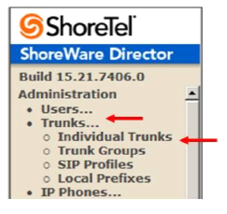

Figure 2 –Call Control Options

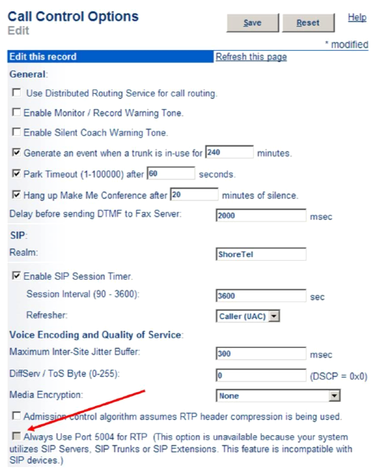

Figure 3 –Edit Call Control Options

1. Confirm that the parameter, ‘Always Use Port 5004 for RTP’ is unchecked or grayed out. Disabling this parameter is required for implementing SIP on the ShoreTel system. For SIP configurations, Dynamic User Datagram Protocol (UDP) must be used for RTP Traffic. If the parameter is disabled, Media Gateway Control Protocol (MGCP) will no longer use UDP port 5004; MGCP and SIP traffic will use dynamic UDP ports. Once this parameter is disabled (unchecked), make sure that ‘everything’ (IP Phones, ShoreGear® Switches, ShoreWare Server, Distributed Voice Mail Servers / Remote Servers, Conference Bridges and Contact Centers) is ‘fully’ rebooted –this is a ‘one time only’ item. By not performing a full system reboot, one-way audio will probably occur during initial testing.
2. Configure the SIP Profile
3. Click the Administration link to expand the submenus
4. Click on SIP Servers
5. Click on SIP Profiles
6. Click on New button

A new SIP Profiles screen is displayed (Figure 5)

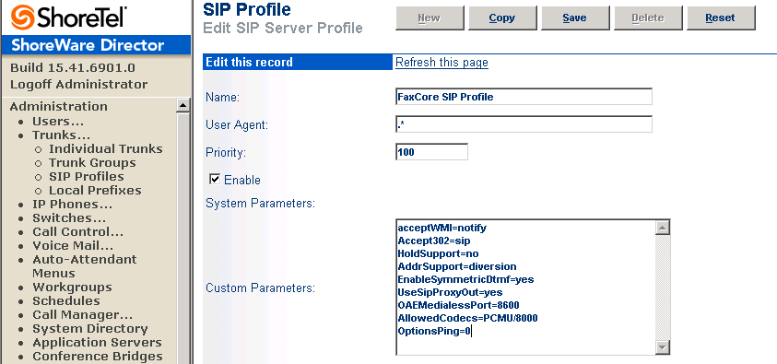

Figure 5 –Edit SIP Server Profile

1. Complete the form to create a new SIP Profile
2. Name: This parameter is the label by which Director refers to the profile
3. User Agent: This parameter is the expression ShoreWare uses to identify devices covered by the profile, it is not used by the SIP servers. The profile cannot be saved without a value, so you should define it as „.*(without the single quotes, should just be period followed by the asterisk).
4. Priority: This parameter lists the status of the profile. The default is 100 and there is no need to modify this parameter.
5. Enabled: This check-box controls whether the profile is available for use. The default is not enabled (not checked) be sure to enable / check this option
6. System Parameters: This field lists the device characteristics and default settings.
7. Custom Parameters: The contents of this field list additional device settings or overwrite default settings listed in the System Parameters field. Make sure to include the following entries in the Custom Parameters (note these are case sensitive):  
   i. acceptMWI=notify  
   ii. Accept302=sip  
   iii. HoldSupport=no  
   iv. AddrSupport=diversion  
   v. EnableSymmetricDtmf=yes  
   vi. UseSipProxyOut=yes  
   vii. OAEMedialessPort=8600  
   viii. AllowedCodecs=PCMU/8000  
   ix. OptionsPing=0

**Note:** Please do not disable any of the default SIP Profiles. In case there are issues with the custom profile defined, disabling the system profiles may cause the FaxCore to not be added to the ShoreTel system. Refer to the ShoreTel Administration Guide for more information.

1. Configure the FaxCore as a SIP UM Server
2. Click the Administration link to expand the submenus
3. Click on SIP Servers
4. Click on SIP Servers
5. Click on the New button

A new SIP Server screen is displayed

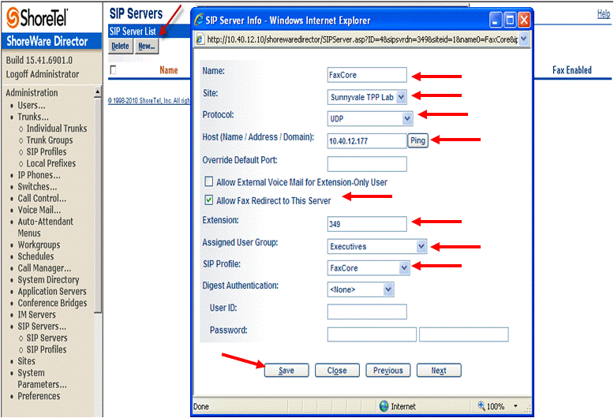

Figure 7 –SIP Server New Screen  
  
Enter the SIP Server information for the new server as described in the table below.

|  |  |
| --- | --- |
| Field | Description |
| Name: | Enter an appropriate descriptive server name |
| Site: | Select the appropriate site location |
| Protocol: | Select UDP |
| Host (Name/Address/Domain): | Enter the IP address of the FaxCore server |
| Override Default Port: | Enter 5060 |
| Allow Ext. Voice Mail for Extension-Only User | Leave unchecked |
| Allow Fax Redirect to This Server | Check this parameter |
| Extension: | The system will automatically assign the next available extension, however you can define a different unused extension. |
| Assigned User Group: | Assign an appropriate user group that has access to the necessary trunks, in this example we selected the ‘Executives’ user group. |
| SIP Profile: | Enter the SIP profile created in previous step, see Figure 5. |
| Digest Authentication: | Leave this as <None> |
| User ID: | Leave blank |
| Password: | Leave blank |

Table 6 - SIP Server Info Requirements

Click Save to store your changes.

1. Enable SIP Proxy Ports on ShoreGear Switch  
   When allocating Ports for SIP extensions, these changes are modified by selecting ‘Administration,’’Switches’ then ‘Primary’ in ShoreWare Director (see Figure 8)
2. Click the Administration link to expand the submenus
3. Click on Switches
4. Click on Primary

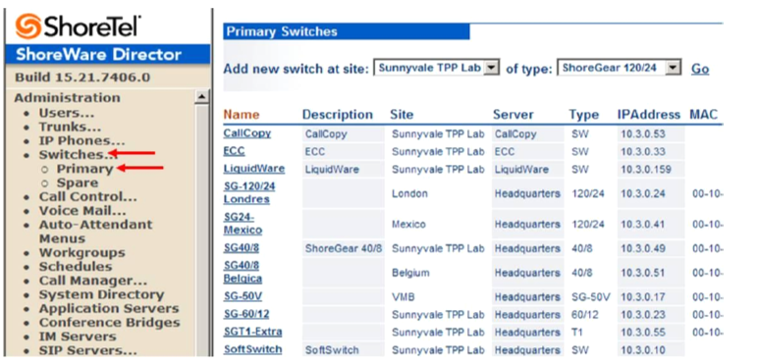

Figure 8 –List of Primary Switches

This action brings up the ‘Primary Switches’ screen. From the ‘Switches’ screen, simply select the name of the switch to configure. The ‘Edit ShoreGear …Switch’ screen will be displayed (see Figure 9). Within the ‘Edit ShoreGear …Switch’ screen, define one of the ‘Port Type’ settings from the available ports to ‘100 SIP Proxy’, then save the change.

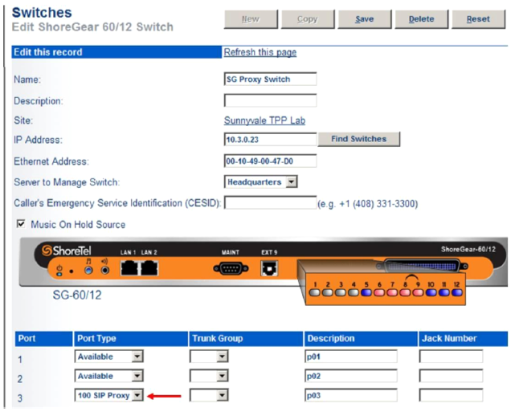

Figure 9 –Edit ShoreGear Switch  
If the ShoreGear switch that you have selected has ‘built-in’ capacity (i.e., ShoreGear 50/90/220T1/E1, etc.) for IP phones and SIP trunks, you can also remove 5 ports from the total number available to provide the ‘100 SIP Proxy’ configuration necessary.  
  
**Note**: Every 5 ports you remove from the total available will result in ‘100 SIP Proxy’ ports being made available. One dedicated ShoreGear 120 switch can act as a proxy for the entire site and support up to 2400 SIP phones.

1. Modifying the Site Settings  
     
   The next settings to addresses are the administration of sites. These settings are modified under the ShoreWare Director by selecting ‘Administration’ then ‘Sites’ (Figure 10)
2. Click on Sites
3. Click on an existing site or add a new site where the users will be using the fax service. In this example, the Sunnyvale TPP Lab is the site where the users are located.

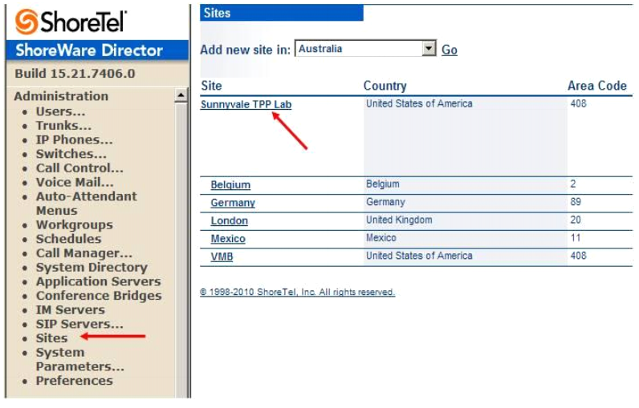

Figure 10 –Sites

Within the ‘Sites’ screen, select the name of the site to configure. The ‘Edit Site’ screen will then appear. Scroll down to the ‘SIP Proxy’ parameters (Figure 11).

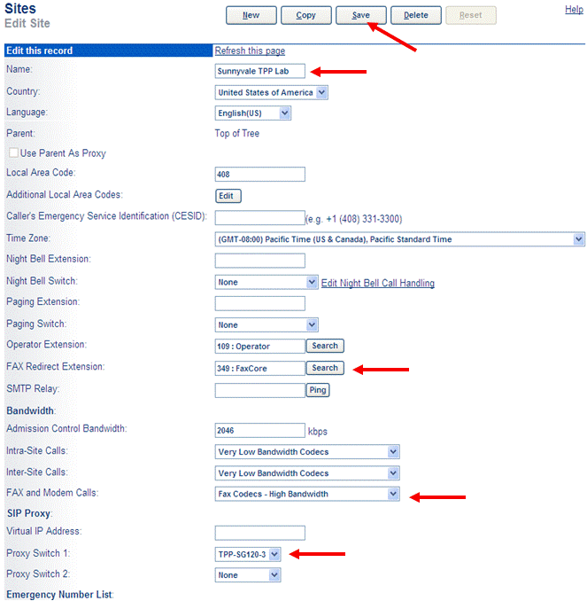

Figure 11 –Edit Site

1. If editing an existing Site, select that Site
2. For the parameter FAX Redirect Extension, click on the search button and select the FaxCore server created earlier, see Figure 7. The FAX Redirect Extension must be an existing user. In this example, the SIP UM Server extension created earlier, 349: FaxCore is the fax redirection number
3. For the parameter FAX and Modem Calls, select ‘Fax Codecs –High Bandwidth’  
   ***Note****: T.38 has been added to the default Codec Lists (Fax Codecs –High Bandwidth and Fax Codecs –Low Bandwidth)*
4. In the ‘SIP Proxy:’parameter area, for the parameter ‘Proxy Switch 1:’, select the appropriate ShoreTel SIP Proxy Switch that supports T.38
5. Click on Save. For additional details on configuring SIP Proxy or Virtual IP Address please refer to the ShoreTel Administration Guide.  
   ***Note:*** *Bandwidth of 2046 is just an example. Please refer to the ShoreTel Planning and Installation Guide for additional information on setting Admission Control Bandwidth.*
6. Modify Individual Users for Fax –Creating a SIP Extension
7. Click on Users
8. Click on Individual Users

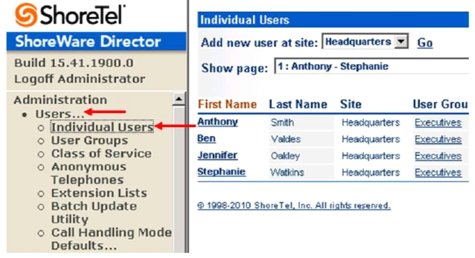

Figure 12 –Individual Users

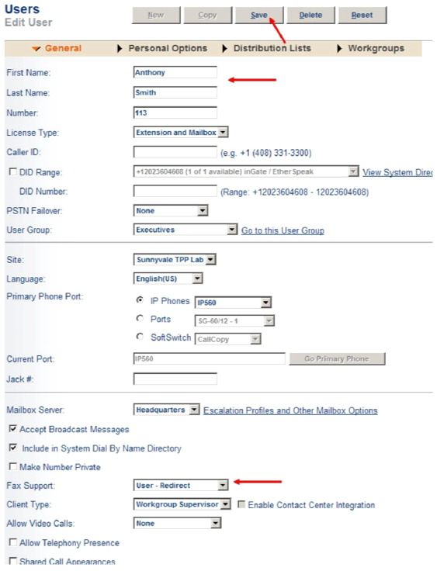

Figure 13 –Edit User

1. Select the user whose fax calls you want to be redirected to the Fax Redirected Extension (FaxCore server). If this is a new user then select any existing user, then click on the New button to create a new user
2. For the parameter ‘Fax Support:’, make sure to select ‘User –Redirect’ (this is the default setting)
3. Click the Save button

Application 2 –User with a Unique Voice Extension and a Unique Fax Extension  
  
ShoreTel’s implementation of fax redirect requires that the call be answered (either by the user or voice mail) in order for the fax call to be redirected to the proper fax redirect extension. Some users prefer not to hear the CNG (fax) tones when receiving fax call, and instead prefer to have a separate fax phone number (DNIS/DID) that would route directly to their fax server (FaxCore), then the fax server would deliver the fax to the user’s email Should your implementation require a unique number for fax that is different from the voice number, then you will need to configure the ShoreTel system and FaxCore Fax server for SIP trunks using Off System Extensions (OSEs) rather than a SIP UM server.  
  
The following steps describe how to configure the ShoreTel system for faxing using SIP Trunks and Off System Extensions (OSEs).  
  
Switch Settings - Allocating Ports for SIP Trunks

These settings are modified by selecting Administration, then Switches followed by Primary in the ShoreWare Director section (Figure 14).

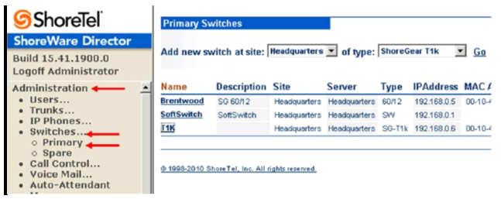

Figure 14 –Switches Administration

This will bring up the Switches screen. From the Switches screen simply select the name of the switch to configure. The Edit ShoreGear Switch screen will be displayed. Within the Edit ShoreGear Switch screen, select the desired number of SIP trunks from the ports available (Figure 15).

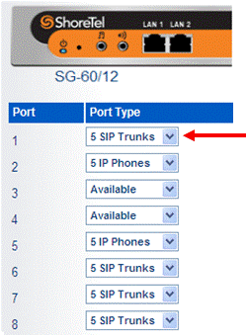

Figure 15 –ShoreGear Switch Settings

Each port designated as a SIP trunk port type enables the support for 5 individual SIP trunks.  
ShoreTel System Settings –Trunk Groups  
ShoreTel trunk groups only support Static IP Address SIP endpoint Individual Trunks.  
The settings for trunk groups are changed by selecting Administration, then Trunks followed by Trunk Groups in the ShoreWare Director section (Figure 16).

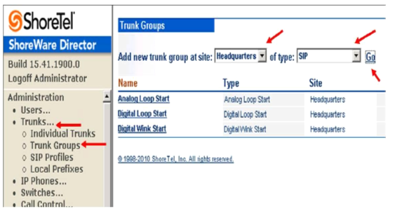

Figure 16–Trunk Groups Administration

From the dropdown menus on the Trunk Groups screen, select the site desired and select SIP as the trunk type to configure. Then click the Go link right from the Type field. The Edit SIP Trunk Group screen will appear (Figure 17).

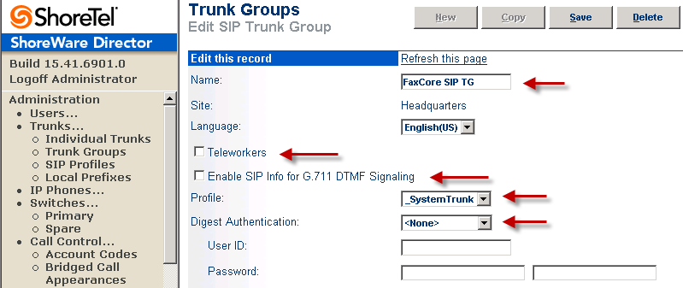

Figure 17–Edit SIP Trunk Group  
  
The next step within the Edit SIP Trunks Group screen is to define the name for the trunk group. Next verify that the setting for the Teleworkers parameter is disabled (checkbox clear). Disabling the Teleworker parameter will configure the trunk group for intra-site calls, which was configured earlier (see Figure 11) for Very High Bandwidth Codecs which has G.711u as one of the preferred codec choices. The Enable SIP Info for G.711 DTMF Signaling parameter should also be disabled (checkbox clear). Enabling SIP info is currently only used with SIP tie trunks between ShoreTel systems. The ‘Profile’parameter defaults to ‘_SystemTrunk’, no further modification is required. The Digest Authentication parameter defaults to <None>; no modification is required here. Next, you need to make the appropriate settings for the inbound parameters in the Edit SIP Trunks Group screen (Figure 18).

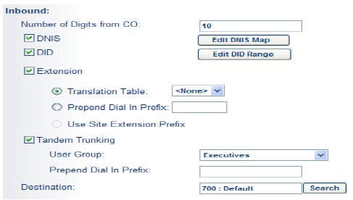

Figure 18 –Inbound Settings

Within the Inbound settings, the Number of Digits from CO should match what the ShoreGear SIP trunk switch will be receiving from this public network and this is usually configured to match the systems extension length. It is not necessary to enable the DNIS or DID parameters as they are not required. Ensure that the Extension and Tandem Trunking checkboxes are selected. For additional information on these parameters refer to ShoreTel´s Planning and Installation Guide. The following section is configured in the same way as any normal trunk group.

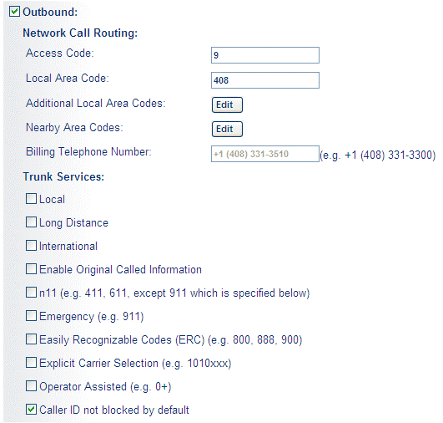

Figure 19 –Outbound and Trunk Services

Select the Outbound checkbox and specify a Trunk Access Code and Local Area Code as appropriate. In the Trunk Services section, there is no real need to enable any specific options as access to FaxCore will be via Off System Extensions (OSE’s). The last parameter (‘Caller ID not blocked by default’), this parameter determines if the call is sent out as <unknown> or with caller information (Caller ID), this parameter should be enabled (checked).  
  
Next, configure the Trunk Digit Manipulation (Figure 20):

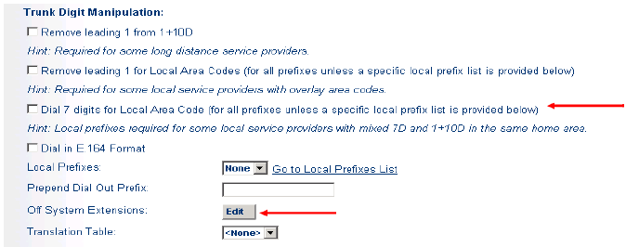

Figure 20 –Trunk Digit Manipulation

You need to define an Off System Extension (OSE), but before you can do so, you’ll need to save your settings by clicking Save to input the changes. You will be prompted to give all User Groups access to this newly created trunk group (see Figure 21). It is not necessary to grant access as connectivity is via Off System Extensions, so click Cancel.

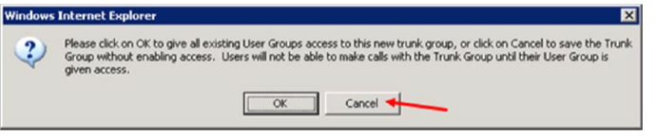

Figure 21 –Grant User Groups access to new Trunk Group

After you have saved your changes you will need to define your Off System Extension range. This can be any extension not currently in use on the ShoreTel system. Click Edit to the right of the Off System Extensions field in the Trunk Digit Manipulation section (see Figure 18), the “Off System Extensions” Ranges dialog will be displayed as shown in Figure 22.

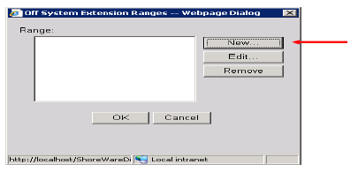

Figure 22 –Off System Extension Ranges  
  
Click New to get the New Range dialog as shown in Figure 23.

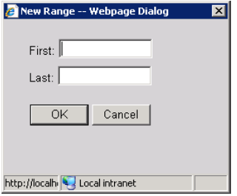

Figure 23 –Off System Extension - New Range Dialog

Define a single extension range that is within your ShoreTel PBX extensions and click OK. This range must match the extension range of the users defined on the FaxCore server. This completes the settings needed to set up the trunk groups on the ShoreTel system.  
Note: Each individual Off System Extension will be an individual user’s fax destination, be certain to add a sufficient OSE range to cover all the individual users that require faxing capabilities.

**ShoreTel System Settings –Individual Trunks**

This section covers the configuration of the individual trunks. Select Administration, then Trunks followed by Individual Trunks to configure the individual trunks (Figure 27).

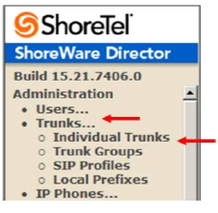Figure 24 –Individual Trunks

The Trunks by Group screen is used to change the individual trunks settings that appear (Figure 25).  
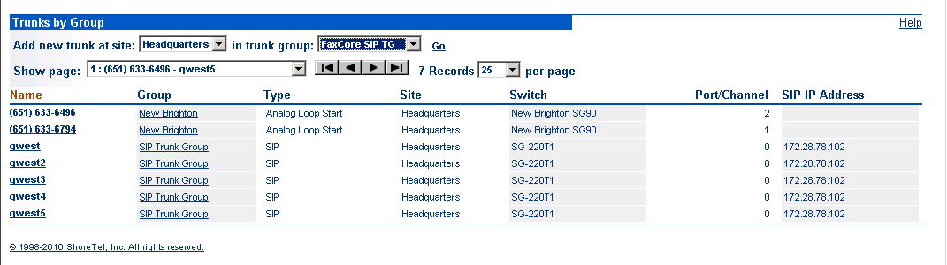

Figure 25–Trunks by Group

Select the site for the new individual trunk(s) to be added and select the appropriate trunk group from the dropdown menus at the top of the screen. In this example, the site is Sunnyvale TPP Lab and the trunk group is FaxCore, as created above, see Figure 17. Click Go to bring up the Edit Trunk screen (Figure 26).

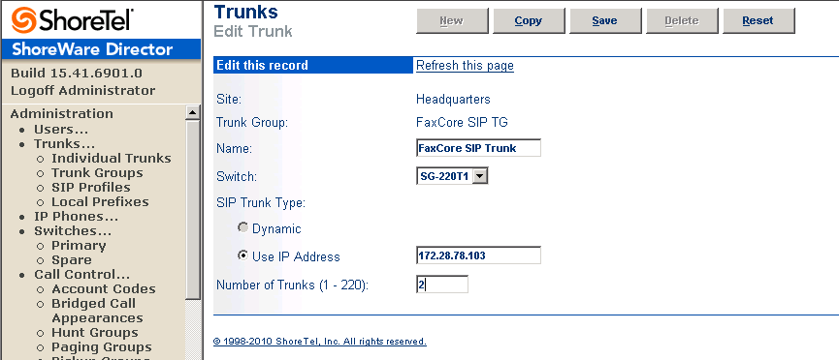

Figure 26 - Edit Trunk Screen for Individual Trunks

On the Edit Trunk screen for individual trunks; enter a Name for the individual trunks. It is recommended to name the individual trunks the same as the name of the trunk group so that the trunk type can easily be tracked. Next, select the appropriate Switch upon which the individual trunk will be created. This will be the ShoreGear switch that you defined to have SIP Trunks, see Figure 16.

For the SIP Trunk Type the only option available is Use IP Address. Specify the IP address of the FaxCore server.

Next enter the number of individual trunks desired into the Number of Trunks field. Each individual trunk supports ‘one’ audio path –example if 10 is configured, then 10 audio paths can be up at one time, meaning that you can have up to 10 fax calls connected at once. Once these edits are complete, click Save to commit the changes.   
After setting up the trunk groups and individual trunks, refer to the ShoreTel Planning and Installation Guide to make the appropriate changes for the User Group settings. This completes the settings for the ShoreTel system side.

FaxCore Configuration  
The FaxCore software will need to be installed on a Windows 2000, 2003 or 2008 server operating system with Microsoft IIS/SMTP installed. FaxCore is supported on a Hyper-V or VMware based virtual machine when using the Brooktrout SR140 for Fax over IP. Additionally, an SMTP connection to either an Internet email account or a local email server will be necessary from the FaxCore server for the fax delivery to a user’s mailbox. The most common mistake is not restarting the FaxCore services following a change in the configuration. Any time a change is made (i.e. adding lines, changing users, etc.) the FaxCore services should be restarted.

### **Configuration for the FaxCore/Dialogic Brooktrout SR140**

1. From the FaxCore server PC, click Start/All Programs/Brooktrout/Brooktrout Configuration Tool

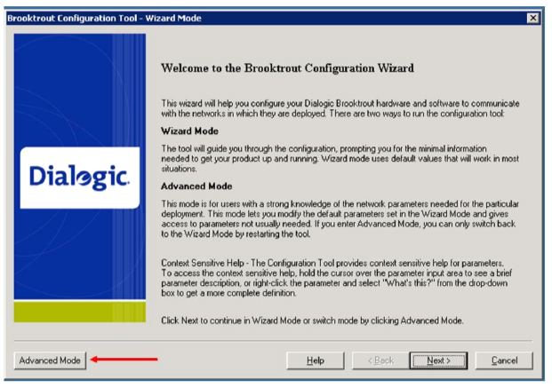

Figure 27 –Brooktrout Configuration Wizard

1. Click on Advanced Mode

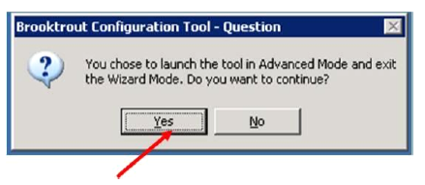  
Figure 28 –Brooktrout Configuration Wizard Question

1. Click on Yes

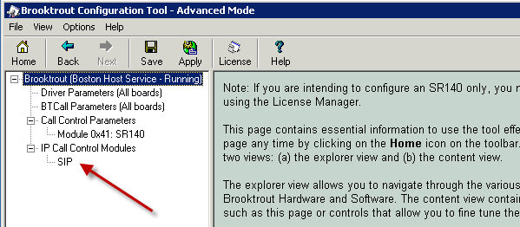

Figure 29 –Brooktrout Configuration Tool Advanced Mode

1. Expand the tree. Click on IP Call Control Modules. Click on SIP

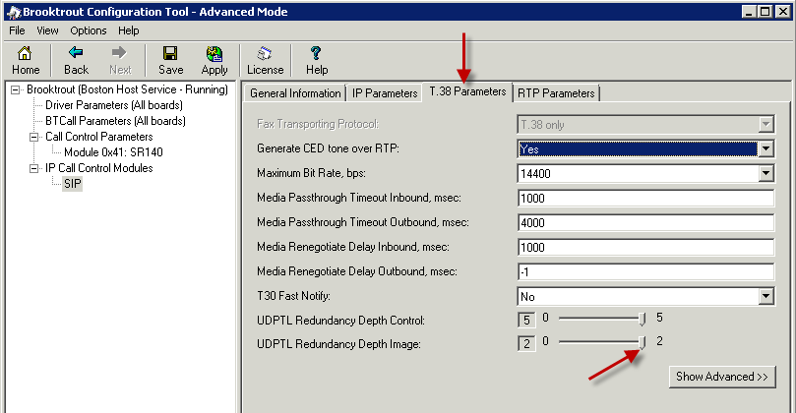

Figure 30 –Brooktrout Configuration Tool Advanced Mode T.38 Parameters

1. Click on T.38 Parameters Tab
2. Adjust the UDPTL Redundancy Depth Image from 0 to 2

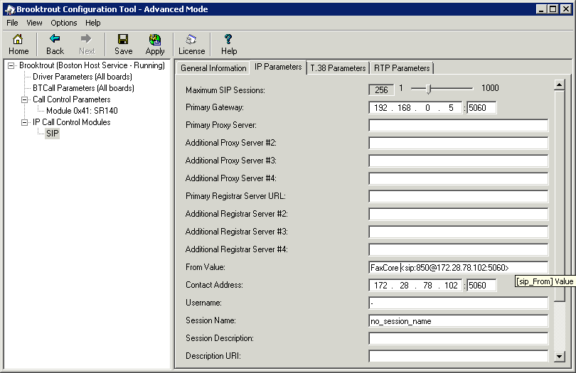

Figure 31 –Brooktrout Configuration Tool Advanced Mode IP Parameters

1. Click on IP Parameters Tab
2. Primary Gateway - Enter the IP address of the ShoreGear SIP Proxy Switch and enter the default SIP UDP port 5060
3. Primary Proxy Server –Leave blank.
4. From Value: - Enter the FaxCore Request URI (For this example - FaxCore sip:850@172.28.78.102:5060), where ‘FaxCore’ is the name thaw will be used in the SIP call request and ‘850’is the extension defined for the FaxCore. After the ’@’you should define the IP address of the FaxCore server followed by a colon ‘:’and 5060.
5. Contact: - Enter the IP address of the FaxCore Fax Server and the SIP UDP port 5060
6. Click on the Show Advanced button

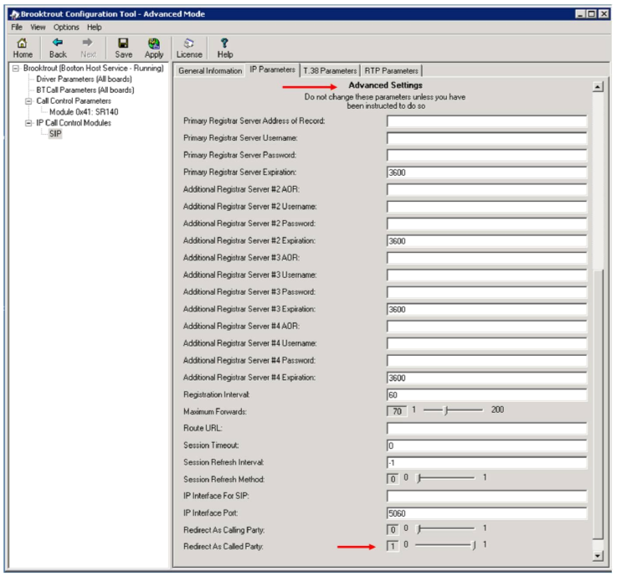

Figure 32 –Brooktrout Configuration Tool Advanced Mode IP Parameters Advanced Settings

1. Redirect As Called Party –Adjust the value from 0 to 1. The parameter tells the FaxCore Server to route fax calls based on the Diversion Header of the Invite message instead of the Request URI.  
     
   Note: Set the ‘Redirect As Called Party’ value to 0 if you are configuring your fax solution using SIP Trunks and Off System Extensions (OSEs) rather than a SIP UM server

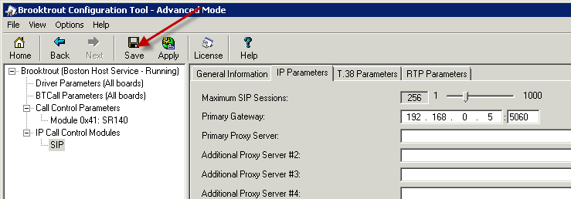

Figure 33 –Brooktrout Configuration Tool Advanced Save

1. Save

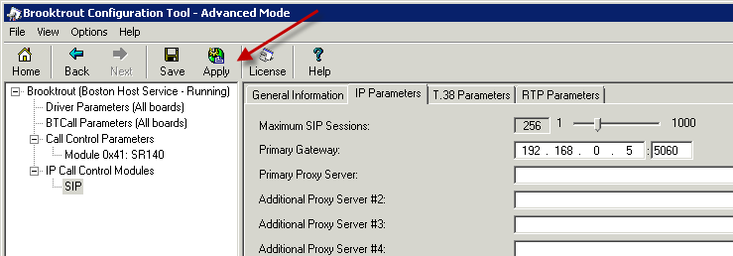

Figure 34 –Brooktrout Configuration Tool Advanced Apply

1. Click on Apply
2. Restart FXC2.FaxAgent service in Windows Service Console.