**Audio codes and XCAPI**

Many fax servers are not even able to handle SIP or T.38, so the software XCAPI from TE-Systems has established itself as a quasi-standard for many servers. This software can, for example, set up corresponding audio and FAX connections via SIP and pass it on to the software as an ISDN CAPI. Thus each fax server, which so far could work with ISDN maps, to the fax server via VoIP. And these are some products in the market. As an example, I have described the configuration with an Audiocodes gateway and what troubles have to be considered. Because both Audiocodes and TE-Systems have published appropriate white papers for setting up fax. Unfortunately, the attitude is not consistent, so the "correct" attitude must be thought together.

* Codec   
  TE-Systems insists that the TOC codec in the coder list is included in the audio code. Audiocodes also offers the codec well in the SDP but TE-Systems does not offer it for its part in the SDP response. Apparently TE-Systems did not know that audio codes also makes T.38 if the codec is not explicitly offered in the list.
* Baud rate   
  Audiocodes recommends setting the fax speed to 33600Baud. However, this does not work for TE systems and complains that the baud rate is too high. 14400 Baud is here the compatible correct value, which TE-Systems also in in its documentation suggests.

If you do not use the "softfax" function, then has proved to me the following setting:

At the controller level, the softfax function is deactivated and the "Enhanced Call Transfer (ETC)" is deactivated:

Codecs must have T.38 UDP activated.

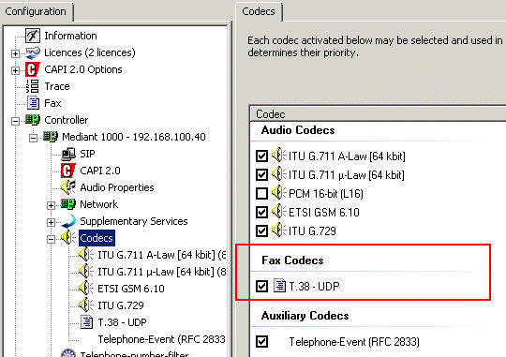

And on the T38 itself "XCAPI preferred" should be active.

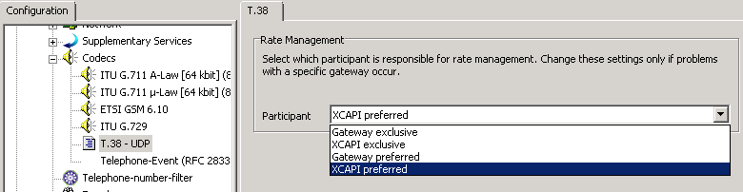

On the side of Audiocodes I have made the following settings good experiences

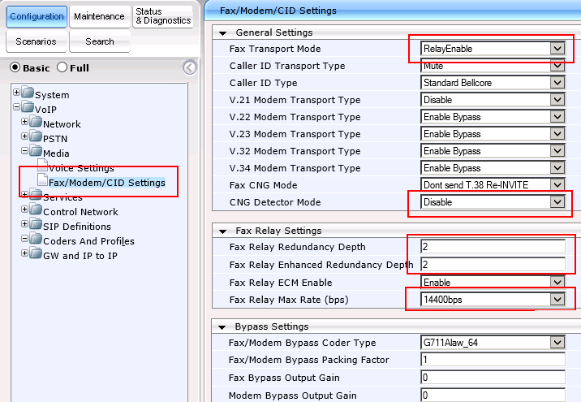

The "Fax Transport Mode" must be set to 1 = RelayEnable, so that T.38 is used. The CNG Detector remains Disabled. The baud rate is fast enough with 14400 and ECM can be activated. Depending on the environment and network, it may be useful to set the "Fax Relay Redundancy Depth to 2 (Default 0) and the" Fax Relay Enhanced Redundancy Depth "to 2 (Default = 4) comes.

There is another parameter, which is listed by TE-Systems specifically with regard to SoftFax and virtual servers. You can adjust the parameter "Dynamic Jitter Buffer Minimum Delay" or per IP profile. The default is 10ms. TE-Systems recommends to set at 80ms.

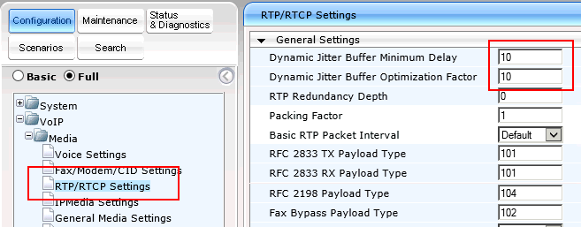

I would do this however not globally, but in an IP profile for the fax goal and refer to this in the routing table.

As mentioned above, the XCAPI guide describes the addition of the T.38 codec. Again, I would never do this globally, but in its own "CoderGroup", which is bound to the IP profile, which is then referenced in the routing table.

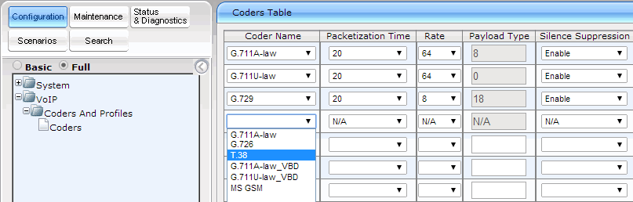

Interestingly, XCAPI provides in the SDP no T.38 as a codec option and with me me the fax receiving thereby problem-free. The G.729 codec is also not available in the list. Here it is not added because of fax, but because a SIP trunk with G.729 bandwidth saves uses.

* Guaranteed Enterprise Fax Service over SIP Trunks (PDF, 213.6KB) Release Date: Oct 25, 11   
  <http://www.audiocodes.com/filehandler.ashx?fileid=1959590>
* V.34 Fax Relay over Packet Networks (PDF, 377.2KB) Release Date: Dec 22, 11   
  <http://www.audiocodes.com/filehandler.ashx?fileid=2127992>