**Sharp OSA 4 MFP Connector Installation Guide**

To do list:

* Access to Faxcore Server
* Download and Install Faxcore – Sharp MFP Connector
* Connector Configuration and Setting
* Sharp MFP External Application Setting

Requirements:

* FaxCore Server with ASP .NET v4
* Sharp MFP that supports OSA and Network Scanning Module
* MS Exchange Server and Active Directory ( Required if Exchange Address access is enable)
* Administrator access to FaxCore server and MFP Web control Panel

**Installation Process**

The following process to be carried out in FaxCore Server only. User has to login to FaxCore server as an Administrator or a user with Administrator privilege.

Step 1:

Download the required Sharp MFP connector files.

Step 2:

Stop all Faxcore Services.

|  |
| --- |
|  |

* FXC3.Dispatcher
* FXC3.FaxAgent
* FXC3.GatewayAgent
* FXC3.RenderAgent

Step 3:

Click on “Start > Administrative Tool > Internet Information Services (IIS)” and Stop FaxCore Web Site.

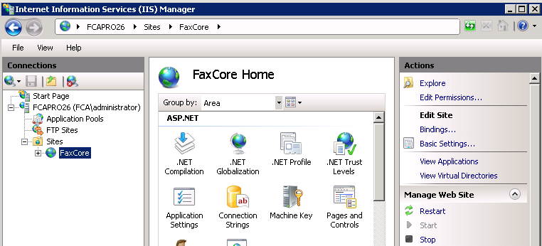

Step 4:

Extract the Sharp Connector files to (eg. C:\FaxCore\web\)

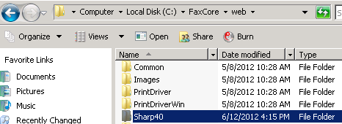

Step 3:

Load back the Internet Information Services (IIS) window and click refresh. You should be able to the “Sharp40” folder.

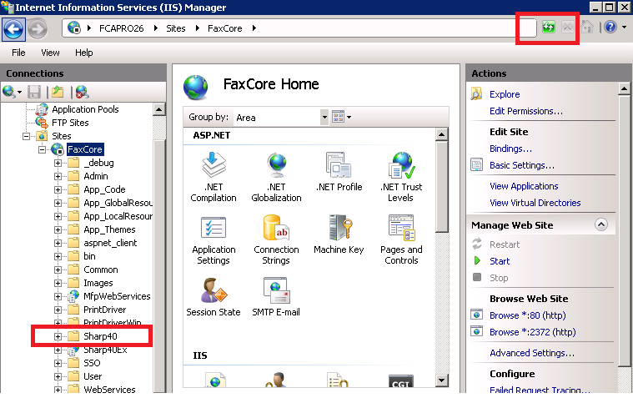

Step 4:

Convert “Sharp40” Folder to Application.

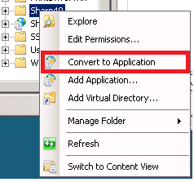

Once is converted, it will prompt an “Add Application” window. On the “Application pool” button, click Select and choose “ASP .NET v4.0.

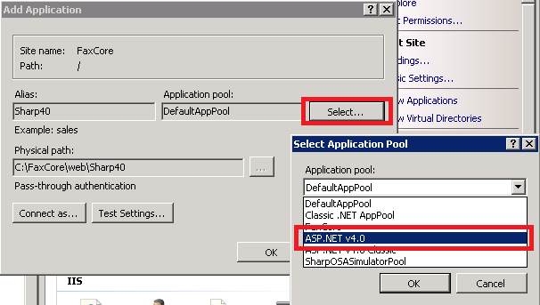

Step 5:

Start back FaxCore Web Sites on IIS and all FaxCore Services.

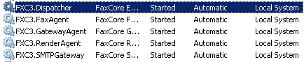

Step 6:

Open up Internet Explorer browser and put in this URL “http://localhost/Sharp40/login.aspx” for a quick test.

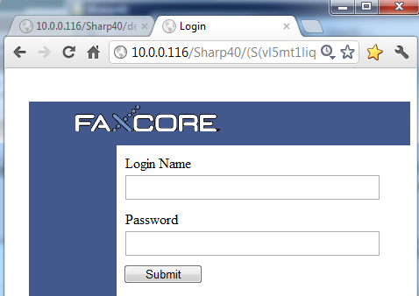

**Configuration**

Go to the Directory (eg. C:\faxcore\web\sharp40) and open up web.config with notepad. Scroll all the way to the end of the document and you will see a section called <appSetting>. This section contains all the settings required by the connector. Each key is represented by a value. You need to replace the value according to your setup environment.

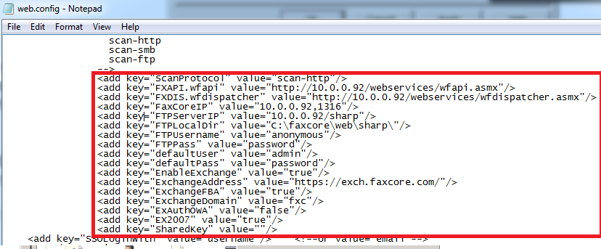

Exchange settings consist of key:

* defaultUser
* defaultPass
* EnableExchange
* ExchangeAddress
* ExchangeFBA
* ExchangeDomain
* ExAuthOWA
* EX2007

FTP settings consist of key:

* FTPServerIP
* FTPLocalDir
* FTPUsername
* FTPPass

FaxCore settings consist of key:

* FXAPI.wfapi
* FXDIS.wfdispatcher
* FaxcoreIP

Sample below:

                                <add key="ScanProtocol" value="scan-http"/>

                                <add key="FXAPI.wfapi" value="<http://localhost:2372/webservices/wfapi.asmx>"/>

                                <add key="FXDIS.wfdispatcher" value="<http://localhost:2372/webservices/wfdispatcher.asmx>"/>

                                <add key="FaxCoreIP" value="localhost\fxcdb"/>

                                <add key="FTPServerIP" value="10.0.0.92/sharp"/>

                                <add key="FTPLocalDir" value="C:\faxcore\web\sharp\"/>

                                <add key="FTPUsername" value="anonymous"/>

                                <add key="FTPPass" value="password"/>

                                <add key="defaultUser" value="admin"/>

                                <add key="defaultPass" value="password"/>

                                <add key="EnableExchange" value="true"/>

                                <add key="ExchangeAddress" value="<https://exch.faxcore.com/>"/>

                                <add key="ExchangeFBA" value="true"/>

                                <add key="ExchangeDomain" value="fxc"/>

                                <add key="ExAuthOWA" value="false"/>

                                <add key="EX2007" value="true"/>

                                <add key="SharedKey" value=""/>

**Configuring Sharp OSA**

Step 1:

Access your Sharp OSA Administration page using browser

Step 2:

Go to > Applications Setting > External Applications Settings >

Enter “FaxCore” in the “Application Name:” text box entry. As for the “Address for Application UI:”, enter [http://*faxcoreserver*/Sharp40/Default.aspx](http://faxcoreserver/Sharp40/Default.aspx) and set the timeout to “60”

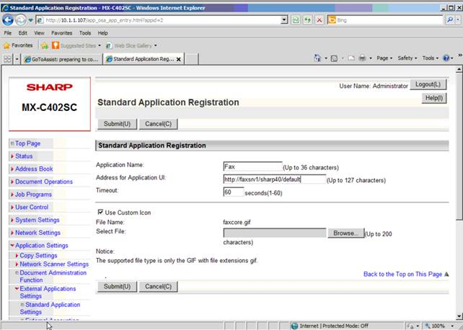

Click on **Submit(U)** button when you have confirmed with the entry to create a link to FaxCore connector. You need to reboot the MFP to register the changes. You can do it from the Web Control Panel or the MFP machine.

**Sharp MFP Interface**

Log in with FaxCore Username and Password.

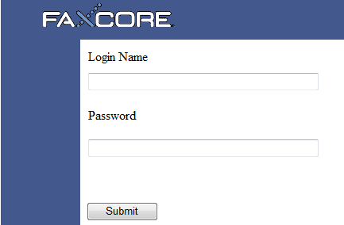

Sending a Fax

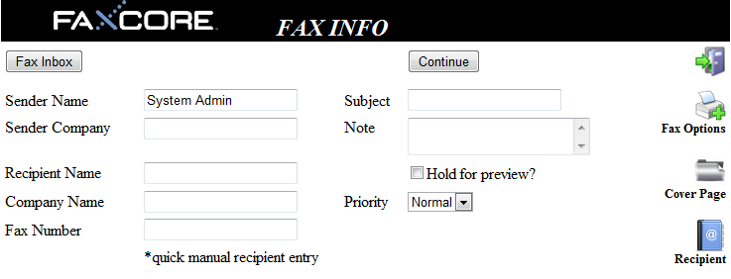

Fax Options

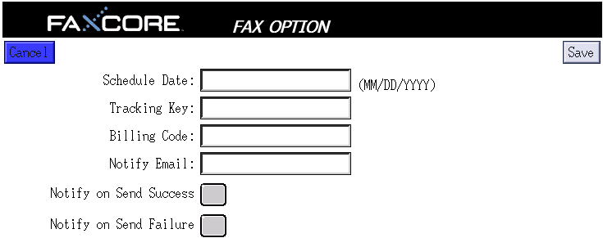

Cover Pages

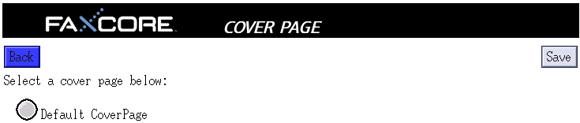

FaxCore Address Book

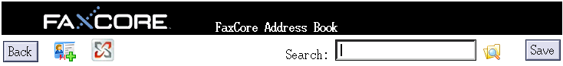

FaxCore User Inbox

