# FaxCore-Xerox EIP Connector Setup Instructions

FaxCore-Xerox EIP connector is a web access module for Xerox EIP enable MFP only. Allows users to send fax directly from Xerox MFP via FaxCore. Verify you Xerox MFP has the EIP module. If this module is not present ask about the alternative method of sending faxes using the “SERVER FAX” button on your Xerox MFP.

## FaxcoreFTP Installation – Add a FaxCoreFTP site to the server. Follow instructions “Set up FaxcoreFTP for Xerox connector”

## Xerox Web Installation

This will configure FaxCore to accept and process files from Xerox EIP devices.

Extract installation file and you will find “XeroxWeb” and “reg client” folders.

* Copy “XeroxWeb” folder to \\FaxCore\web\ directory.
* Add “Network Service” with FULL CONTROL permission to the XeroxWeb folder.
* Locate web.config file in XeroxWeb folder and open with Notepad.exe  
  Look for this section below:

<appSettings>

<add key="MFPMode" value="https"/>

<add key="FaxCoreServer" value="localhost\fxcdb"/>

<add key="DefaultUser" value="admin"/>

<add key="DefaultPass" value="password"/>

<add key="FTPServerIP" value="10.1.200.12"/>

<add key="FTPUser" value="anonymous"/>

<add key="FTPPass" value="password"/>

<add key="FTPLocalDir" value="C:\FaxCore\xgateway\xerox\"/>

<add key="EnableExchange" value="false"/>

<add key="ExchangeOWAURL" value="http://exchangeserver/owa"/>

<add key="ExchangeDomain" value="GIZMO"/>

<add key="ExchangeFBA" value="false"/>

<add key="FXAPI.wfapi" value="http://localhost:2372/webservices/wfapi.asmx"/>

<add key="Template.templateManagement" value="http://localhost/webservices/office/template_management/1/"/>

</appSettings>

|  |  |
| --- | --- |
| **KEYS** | **VALUE + Description** |
| MFPMode | Default value is “HTTPS”. This is access mode set in MFP. |
| FaxCoreServer | Default value is “localhost\FXCDB”. This value change when FaxCore DB is located at external location. |
| DefaultUser | Default user name to access FaxCore. This is applicable for user who would like to disable authentication. |
| DefaultPass | Default password to access FaxCore. This is applicable for user who would like to disable authentication. |
| FTPServerIP | Change this value to FaxCore server IP. MFP will save all scanned image to this address. Default value is “anonymous”. |
| FTPUser | If the above FTP address require authentication, please enter the username here. |
| FTPPass | If the above FTP require authentication, please enter the user’s password here. |
| FTPLocalDir | This is the directory where FTP is set to drop scanned image. Value shown is the default directory where image is saved. Directory name is according to FaxCore setup. |
| EnableExchange | Set value to “true” to enable Outlook address book access. Default value is “false”. |
| ExchangeOWAUrl | Set Exchange server OWA URL. Remember to include HTTPS or HTTP. |
| ExchangeDomain | AD domain name required to access Exchange server. |
| ExchangeFBA | FBA or form-based authentication setting. Set to ‘true” if OWA authentication is set to form-based (HTTPS) or “false” if otherwise (HTTP). |
| FXAPI.wfApi | No changes necessary. |
| Template.templateManagement | No changes necessary. |

Make sure FTPLocalDir directory path is correct.

Make the appropriate changes to the settings and save the file.

* Launch IIS Manager. Expand “Web Sites” > FaxCore, select XeroxWeb in the folder list.
* Right click on “XeroxWeb” and select “Convert to Application”. Click OK.
* Click on “XeroxWeb” then right click on “Default Document” then “Open Feature”. Delete all entries. Then right click and “Add”. Enter “login.aspx” then OK.

To test the connector, launch internet browser and go to <http://faxcore_server/xeroxweb/login.aspx>   
The browser will load the login page and key in your FaxCore credential. Upon success, it will redirect you to the main UI.

If you are unable to load the login page, please check you IIS settings. If you are unable to login, please check your “FaxCoreServer” value against the FaxCore web.config.

## Client/MFP Registration

This application will reach out to each Xerox MFP and place the FaxCore icon on the MFP. In order to access FaxCore in Xerox MFP, MFP needs to register FaxCore module as an application.

1. Navigate to the “Reg Client” folder from your Xerox connector download.
2. Open “Faxcore_eip.xml” file with notepad. Change the IP address in three locations to the local Faxcore servers IP. Save and close.

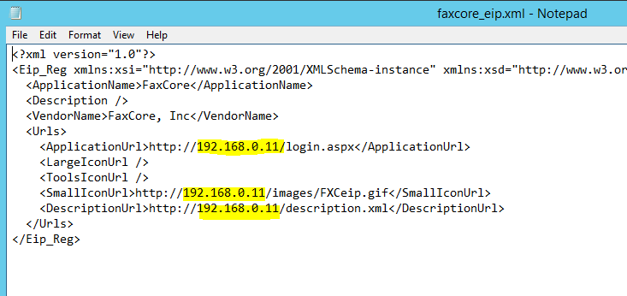

1. Right click on “FXRegister.exe” and run as Administrator.
2. Enter the MFP’s IP or DNS, user name and password (default is admin and 1111). Click “Connect” button to establish a connection with the MFP. If the credential is correct, both “List” and “Create New” button will be enable.

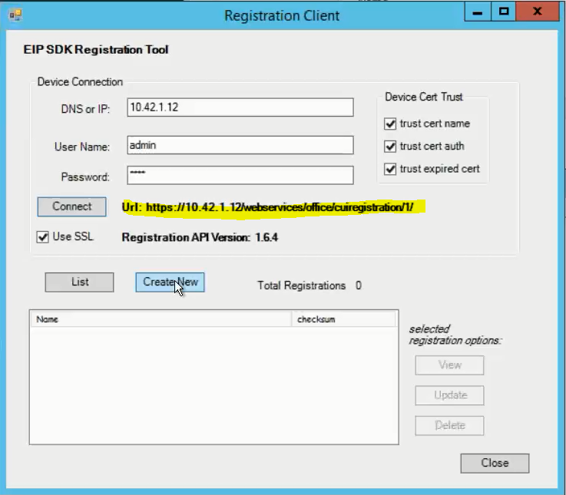

1. Click “Create New” button to launch a new window.
2. Click “Load from XML” button at the bottom and select “faxcore_eip.xml” and open. Click “Create. You will notice all the field has been filled up. Verify that the IP address you see is the IP of the FaxCore server. If not you missed step 2.

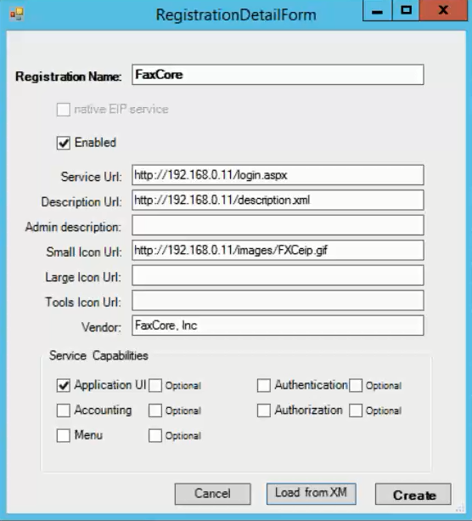

1. Click CREATE.
2. You will need to do this for each Xerox EIP MFP.